**Experiment 1: Getting Started - Tableau Workspace, Tableau terminologies, basic functionalities.**

**Objective:**

Familiarize yourself with Tableau workspace and basic functionalities using the provided sample data file.

**Materials Needed:**

* Tableau Desktop installed on your computer.
* Sample data file: Sample Data File.

**Procedure:**

**1. Download the Sample Data File:**

* Click on the [link](https://view.officeapps.live.com/op/view.aspx?src=https%3A%2F%2Fchandoo.org%2Fwp%2Fwp-content%2Fuploads%2F2023%2F03%2Fsample-data-10mins.xlsx&wdOrigin=BROWSELINK) to download the sample data file.
* Save the file (named sample-data-10mins.xlsx) to a convenient location on your computer.

**2. Open Tableau Desktop:**

* Launch Tableau Desktop from your Start menu (Windows) or Applications folder (macOS).

**3. Connect to the Sample Data:**

* **Start a New Project:**
  + On the Tableau Home screen, click on “Connect” to a data source.
* **Import the Data:**
  + Under the “Connect” pane on the left, click on “Microsoft Excel.”
  + Navigate to the location where you saved the sample-data-10mins.xlsx file and select it.
  + Click “Open” to load the data into Tableau.

**4. Explore the Data:**

* **Data Source Tab:**
  + Tableau will open the “Data Source” tab where you can see a preview of the data.
  + Ensure that the data is correctly loaded and displayed. You can inspect different sheets or tables within the Excel file.

**5. Create a Basic Visualization:**

* **Navigate to a New Worksheet:**
  + Click on the “Sheet 1” tab at the bottom of the screen to open a new worksheet.
* **Build a Simple Visualization:**
  + Drag a dimension (e.g., Category) from the Data Pane on the left to the Rows shelf.
  + Drag a measure (e.g., Sales) from the Data Pane to the Columns shelf.
  + Tableau will automatically generate a basic chart (e.g., a bar chart showing sales by category).

**6. Format the Visualization:**

* **Adjust Titles and Labels:**
  + Click on the chart title to edit it.
  + Right-click on axis labels or data points to format them (e.g., changing font size or color).

**7. Save Your Work:**

* **Save the Workbook:**
  + Click on “File” in the Menu Bar and select “Save As.”
  + Choose a location on your computer, provide a name for the file, and click “Save.”

**8. Practice Exercise:**

* Create a bar chart showing sales by category using the sample data.
* Save your workbook and take a screenshot of your chart.

**Screenshots/Illustrations:**

* **Tableau Home Screen:** Tableau Home screen with the "Connect" pane.

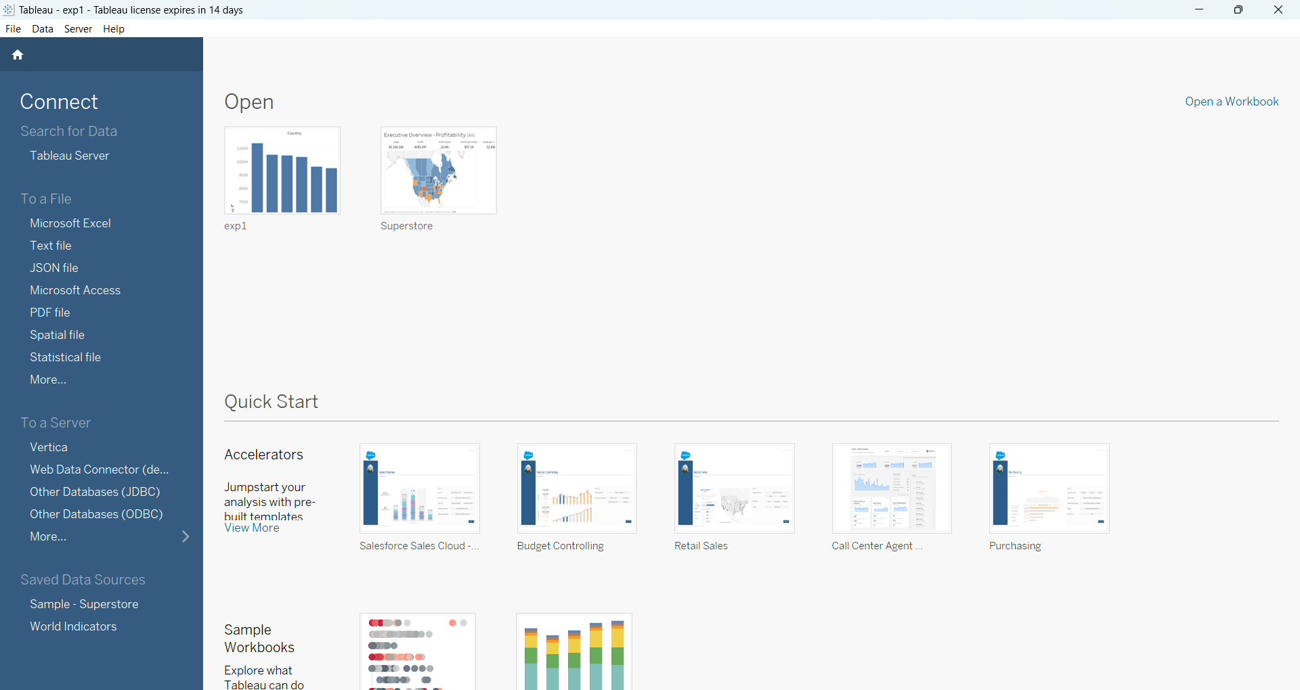

* **Data Source Tab:** Show the data preview from the Excel file.

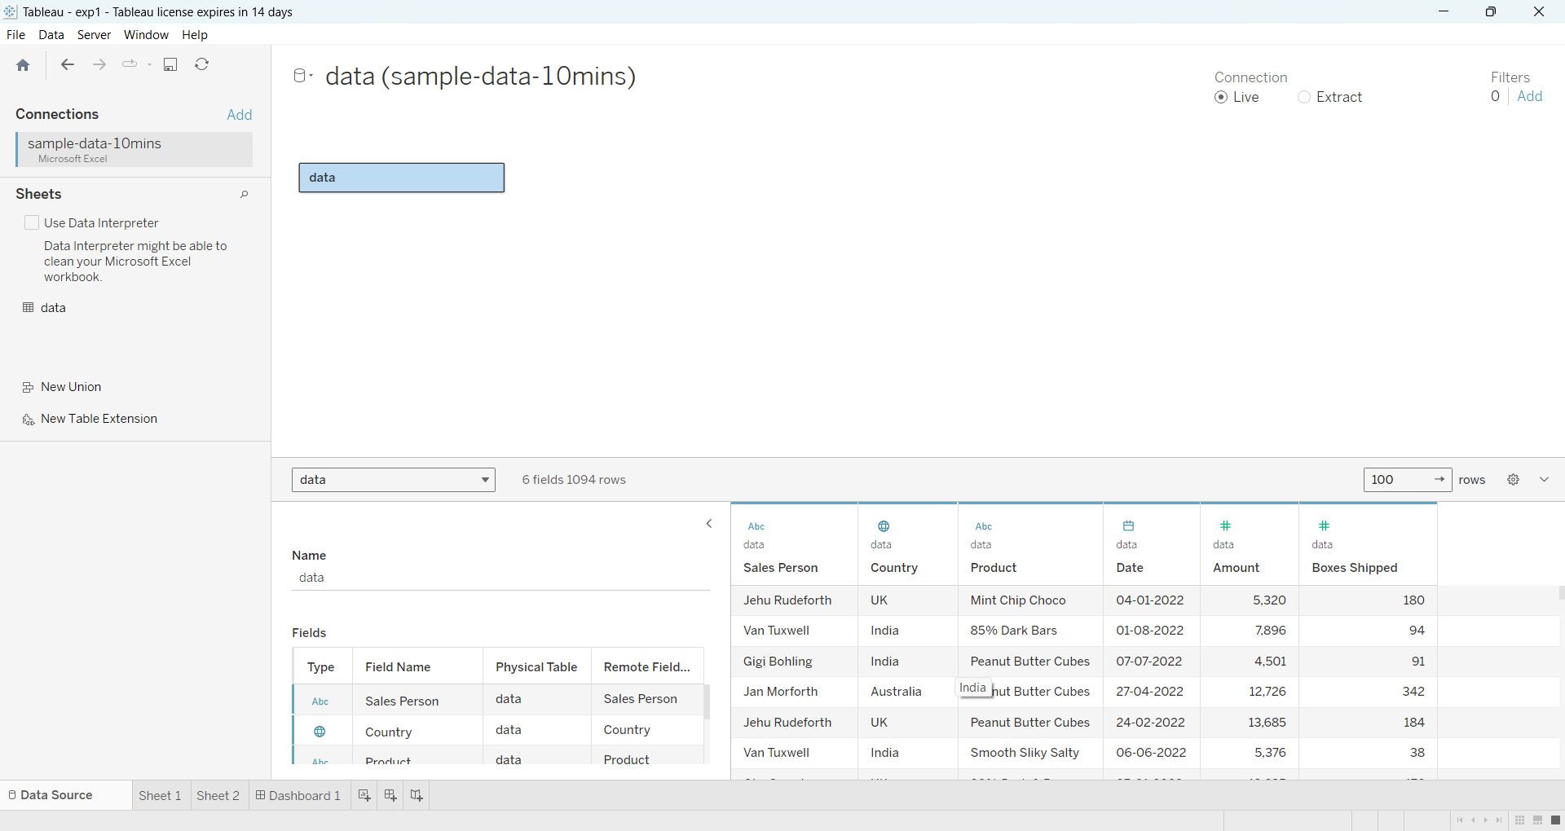

* **Basic Visualization:** Include a screenshot of the bar chart created from the sample data.

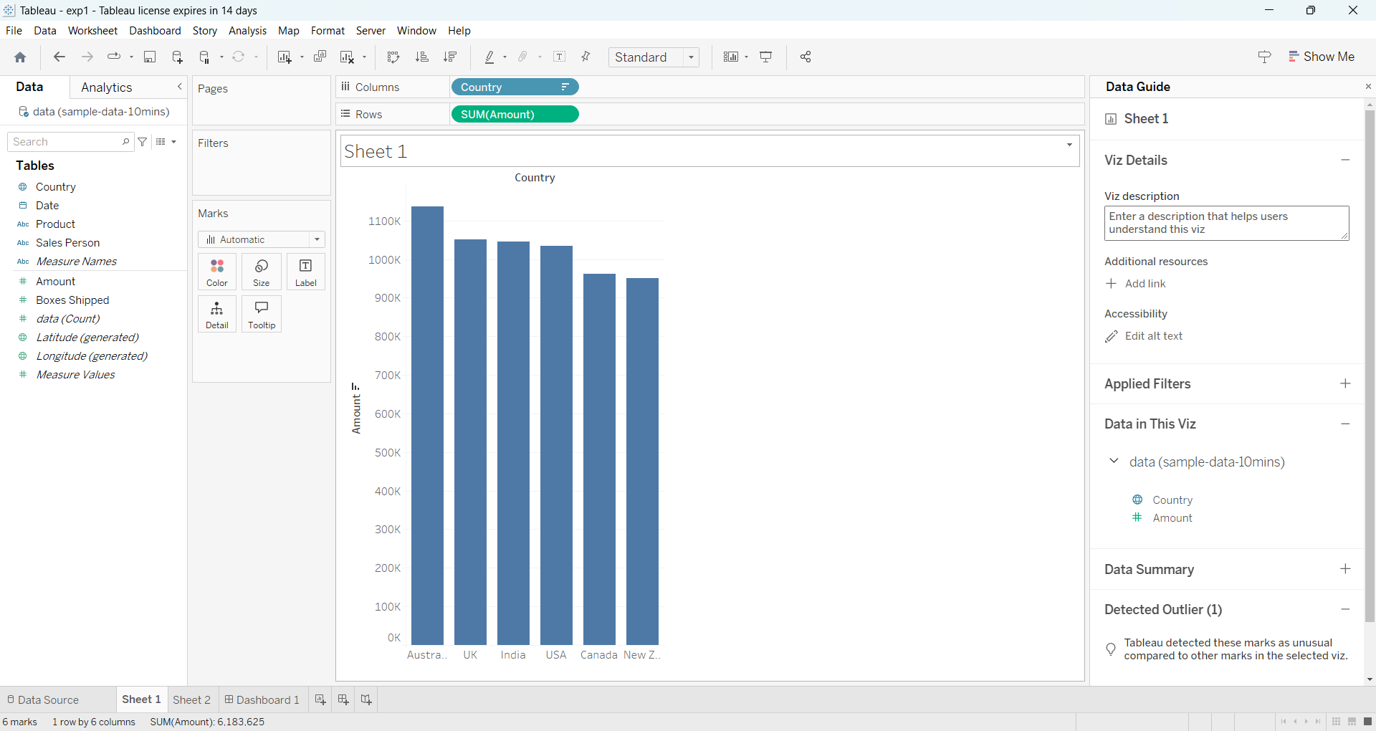

**Expected Outcome:**

* You should be able to connect Tableau to an Excel data source, create a basic visualization, and save your workbook.

**Experiment 2: Connecting to Data Source-** **Connecting to Database, Different types of Tableau Joins.**

**Objective:**

Understand how to connect Tableau to a data source (Excel) and perform different types of Tableau joins (Inner, Left, Right, Full Outer) to combine multiple tables.

**Materials Needed:**

* Tableau Desktop installed on your computer.
* [Tableau Joins File Excel Dataset](https://docs.google.com/spreadsheets/d/17pqSNiOH_m4V2XKjBC8NZdHbTIXx2biR/edit?usp=sharing&ouid=103335543980252346337&rtpof=true&sd=true) from GitHub (download it directly from the GitHub page).

**Procedure:**

**1. Download the Data File:**

* Download the file Tableau Joins File.xlsx from the GitHub repository.
* Save the file to your local machine for easy access.

**2. Open Tableau Desktop:**

* Launch Tableau Desktop on your computer.

**3. Connect to the Excel Data Source:**

* In the Tableau Start page, under **Connect**, select **Microsoft Excel**.
* Navigate to the location where you saved the downloaded file, Tableau Joins File.xlsx, and click **Open**.

**4. Data Source Tab:**

* Tableau will open the **Data Source** tab, displaying the Excel sheets available in the file
* Drag the Demographics table to the workspace.
* Next, drag the Job Title table to the right of Orders. Tableau will automatically suggest a **Join**.

**5. Performing Different Types of Joins:**

* Tableau will default to an **Inner Join**.
* **Edit the Join Type:**
  + Click on the small **Venn diagram** icon between the two tables to edit the join type.
  + You will see options for:
    - **Inner Join**: Only includes rows that match in both tables.
    - **Left Join**: Includes all rows from the left table and matching rows from the right.
    - **Right Join**: Includes all rows from the right table and matching rows from the left.
    - **Full Outer Join**: Includes all rows from both tables, matching where possible.
* **Experiment with Join Types:**
  + Try changing the join type by selecting different options (Inner, Left, Right, and Full Outer) to see how the data changes.
  + **Join Condition:** The common field between the two tables is typically Employee Id.

**6. Explore the Data After Joining:**

* After selecting the appropriate join type, Tableau will display the combined data.
* You can also apply filters to limit the data if needed.

**7. Create a Visualization Using the Joined Data:**

* Navigate to a new worksheet by clicking on **Sheet 1**.
* **Build a Simple Visualization**:
  + Drag Category from the Orders table to **Rows**.
  + Drag Sales from the Orders table to **Columns**.
  + Drag Returned from the Returns table to **Color** to visualize how many items have been returned across different categories.

**8. Formatting the Visualization:**

* **Change Chart Type:** You can right-click the chart and change it to a bar chart or pie chart based on your preferences.
* **Adjust Labels and Colors:** Right-click on the labels and select **Format** to adjust fonts and colors as needed.

**9. Save Your Tableau Workbook:**

* Save your Tableau workbook by going to **File > Save As**.
* Name your file (e.g., Tableau_Joins_Analysis.twb) and save it to your computer.

**Screenshots/Illustrations:**

* **Data Source Tab:** Show a screenshot of the joined tables in the Data Source tab.

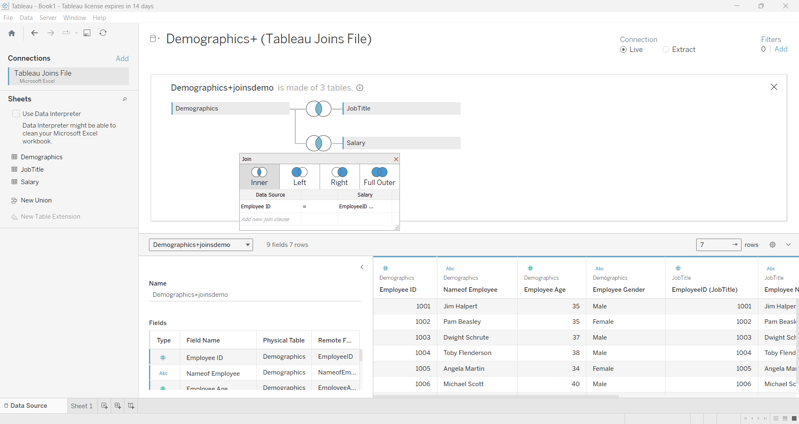

* **Visualization:** Include a screenshot of the visualization you created using the joined data.

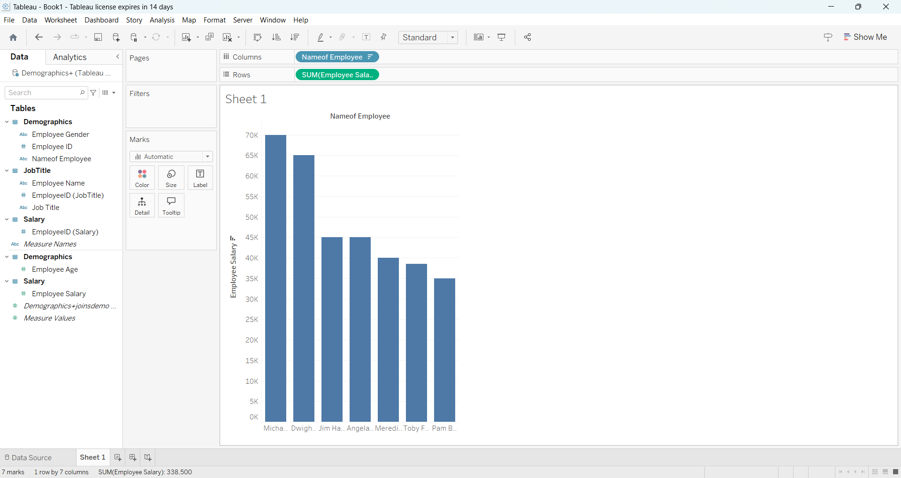

**Expected Outcome:**

* You will learn how to connect to an Excel data source, perform various types of joins, and create a visualization using the combined data from multiple tables.

**Experiment 3: Creating a View - Formatting Charts, Adding Filters, Creating Calculated Fields, and Defining Parameters.**

**Objective:**

To create and format charts in Tableau, apply filters, create calculated fields, and define parameters using the provided **Sales and Category** Excel file.

**Materials Needed:**

* Tableau Desktop installed on your computer.
* The provided Excel file with **Sales** and **Category** data: Download the file here.

**Procedure:**

**1. Open Tableau Desktop:**

* Launch Tableau Desktop.

**2. Connect to the Data Source:**

* In Tableau, under the **Connect** pane on the left, click on **Microsoft Excel**.
* Select the file ([sales_category_data.xlsx](https://docs.google.com/spreadsheets/d/1EpONv0qCpTIqaB2a2YaTsmBKA6AQ6s-23ojKqXIfCFc/edit?usp=sharing)) from your system.
* After loading the data, the sheet will appear in the **Data Source** tab.

**3. Creating a Basic View (Bar Chart):**

* **Drag Fields to Build the Chart:**
  + Drag Category from the Data Pane to the **Rows** shelf.
  + Drag Sales to the **Columns** shelf.
  + Tableau will automatically create a **bar chart** showing total sales for each category.

**4. Formatting the Chart:**

* **Change the Title:**
  + Double-click on the chart title to rename it (e.g., “Total Sales by Category”).
* **Modify Colors:**
  + Right-click on the chart and select **Format** to modify the chart’s colors, fonts, or borders.

**5. Adding Filters:**

* **Drag Fields to Filters:**
  + Drag Category to the **Filters** shelf.
  + In the filter dialog box, select the categories you want to display (or leave all selected).
* **Show the Filter:**
  + Right-click on the Category filter in the **Filters** shelf and choose **Show Filter**. This adds an interactive filter control to the dashboard.

**6. Creating Calculated Fields:**

* **Define a Calculated Field:**
  + Go to **Analysis > Create Calculated Field**.
  + Name the calculated field **Sales Growth**.
  + In the formula editor, enter a calculation. For example, if we had previous year sales, you could calculate growth. For now, use a placeholder calculation:

**Formula:** [Sales] * 1.1

* + This calculation increases the sales by 10% to simulate sales growth.
* **Use the Calculated Field:**
  + Drag the newly created Sales Growth field from the Data Pane to the **Columns** shelf. It will create a comparison between Sales and Sales Growth.

**7. Defining Parameters:**

* **Create a Parameter:**
  + Right-click on the Data Pane and select **Create Parameter**.
  + Name the parameter **Sales Threshold**.
  + Set the **Data Type** to **Float** or **Integer**, and define a range (e.g., from 1000 to 5000).
* **Create a Filter Using the Parameter:**
  + Create a new calculated field named **Above Threshold** with the following logic:

IF [Sales] > [Sales Threshold] THEN "Above Target" ELSE "Below Target" END

* **Show Parameter Control:**
  + Right-click on the Sales Threshold parameter and choose **Show Parameter Control**. This will add an interactive parameter slider to adjust the threshold for sales.

**8. Save the Tableau Workbook:**

* Go to **File > Save As**.
* Name the file (e.g., Experiment3_SalesCategory_Workbook.twb) and save it.

**Screenshots/Illustrations:**

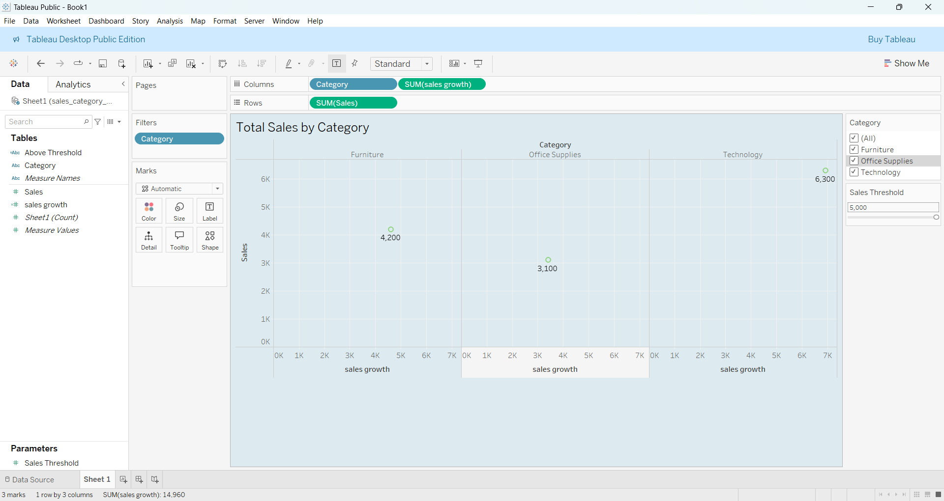

**Expected Outcome:**

You will have created a bar chart, applied filters, used a calculated field for sales growth, and defined a parameter to filter sales data dynamically.

**Experiment 4: Components of Dashboard, Understanding how to place worksheets in Containers, Action filters and its types.**

**Objective:**

To design a Tableau dashboard with multiple views, arrange worksheets in containers, and use action filters for an interactive storytelling experience.

**Materials Needed:**

* Tableau Desktop
* Excel file: [Download the file here](https://view.officeapps.live.com/op/view.aspx?src=https%3A%2F%2Fchandoo.org%2Fwp%2Fwp-content%2Fuploads%2F2023%2F03%2Fsample-data-10mins.xlsx&wdOrigin=BROWSELINK)

**Procedure:**

**1. Open Tableau Desktop and Connect to Data:**

1. Open Tableau Desktop.
2. Under **Connect**, click on **Microsoft Excel**.
3. Select the excel file.
4. Tableau will load the dataset into the **Data Source** tab.

**2. Create Individual Views:**

**Bar Chart: country by amount**

1. Go to **Sheet 1**.
2. Drag Country to the **Rows** shelf.
3. Drag Amount to the **Columns** shelf.
4. A **horizontal bar chart** displaying sales by category will appear.

**Bar Chart: Profit by Region**

1. Go to **Sheet 2**.
2. Drag Sales Person to the **Rows** shelf.
3. Drag Amount to the **Columns** shelf.

**3. Build a Dashboard:**

1. Click **New Dashboard** to create a new dashboard.
2. Drag the worksheets into the dashboard canvas.
3. Adjust the layout by using containers to organize the charts.

**4. Add Action Filters:**

1. Go to **Dashboard > Actions**.
2. Click **Add Action > Filter**.
3. Set up the filter action by selecting one view to filter the other charts (
4. Choose **Select** as the action type and configure the source and target sheets.

**5. Save and Export:**

1. Save the Tableau dashboard by going to **File > Save As**.
2. Optionally, export the dashboard as a PDF or image for reporting purposes.

**Screenshots/Illustrations:**

**Sheet1:**



**Sheet2:**

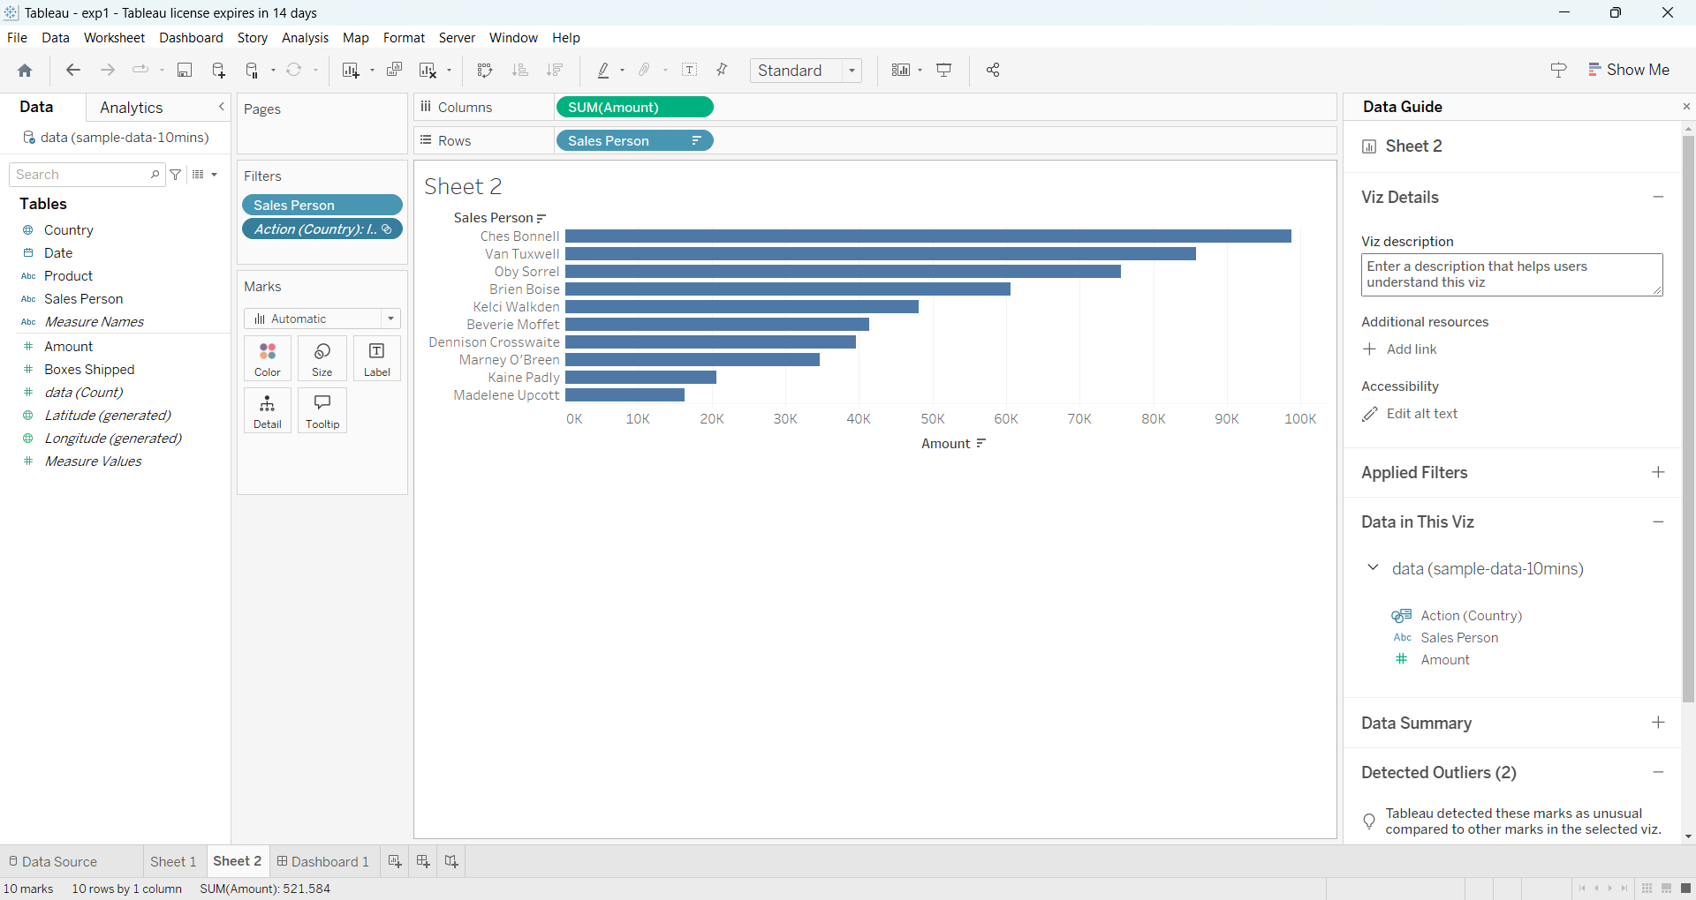

**Dashboard:**

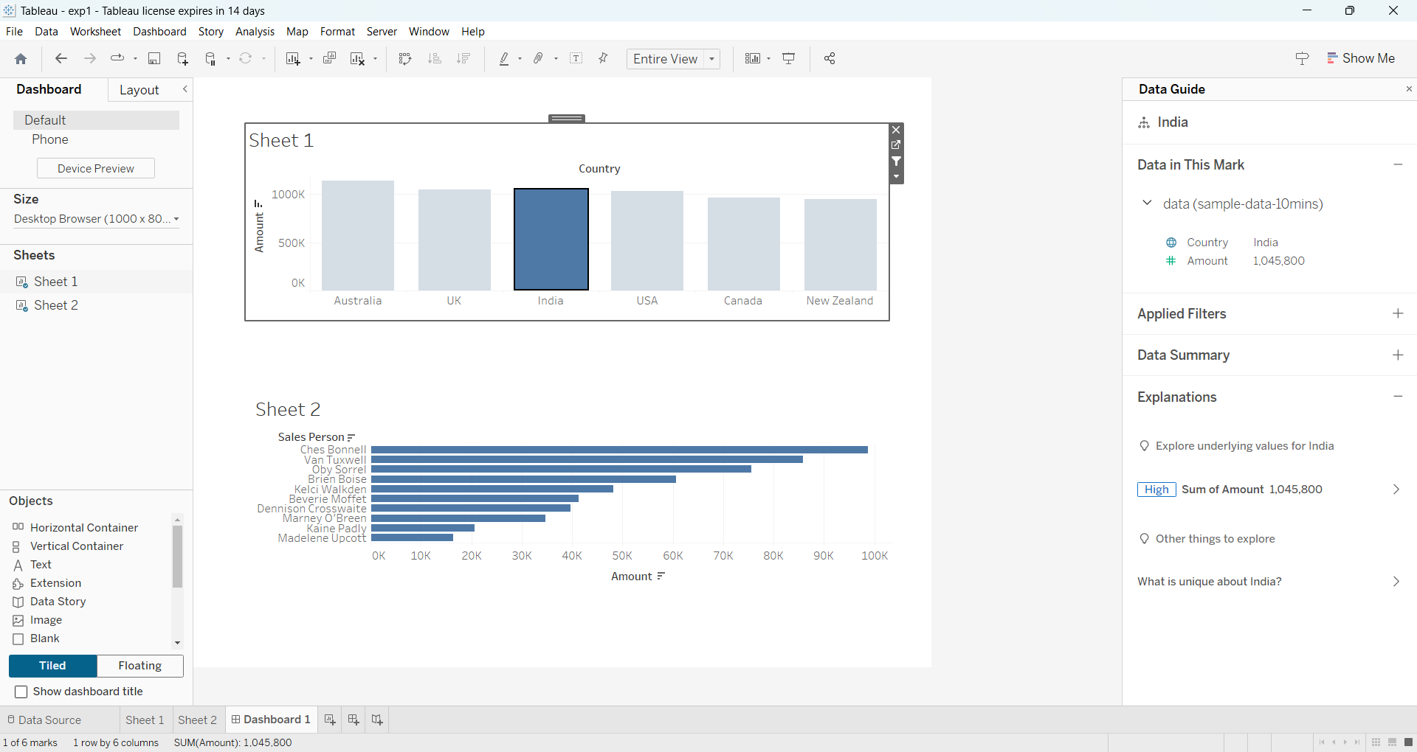

**Expected Outcome:**

You should have a fully interactive Tableau dashboard

**Experiment 5: Introducing Power BI-–Components and the flow of work. Power BI Desktop Interface-The Report has five main areas.**

**Objective:**

* Understand the components and workflow of Power BI.
* Familiarize yourself with the Power BI Desktop interface and its five main areas.

**Procedure:**

1. **Open Power BI Desktop:**
   * Launch the Power BI Desktop application.
2. **Familiarizing with Power BI Desktop Interface:** Power BI Desktop has five main areas:

**a. Ribbon:**  
This is located at the top of the interface and includes options such as Home, Insert, Modeling, View, and Help.

**b. Report View:**  
The workspace where visualizations are created and formatted. It contains Pages that let you have multiple reports on different tabs.

**c. Data View:**  
This area allows you to inspect and interact with the imported data, including adding calculated columns and measures.

**d. Model View:**  
Used for managing relationships between different tables in the data model.

**e. Fields Pane:**  
Located on the right, this displays available datasets, tables, and fields. Fields are dragged to the workspace to create visualizations.

1. **Connecting to Data:**
   * Click on Get Data from the ribbon and select your data source (e.g., Excel, SQL Server, or CSV file).
   * Use this [sample dataset](https://docs.google.com/spreadsheets/d/17pqSNiOH_m4V2XKjBC8NZdHbTIXx2biR/edit?usp=sharing&ouid=103335543980252346337&rtpof=true&sd=true) to follow the experiment.
2. **Loading Data:**
   * After selecting the data file, click Load to import the dataset into Power BI. The dataset will appear in the Fields Pane.
3. **Creating a Simple Report:**
   * Drag a field from the Fields Pane onto the Report View. Create a basic visualization such as a Bar Chart to visualize your data.
4. **Exploring Visualizations:**
   * In the Visualizations Pane, experiment with creating various types of charts (Bar, Pie, Line Charts) using the dataset.
5. **Saving and Publishing:**
   * Save the report by clicking File > Save.
   * Optionally, publish the report to Power BI Service by clicking Publish in the ribbon.

**Screenshots/Illustrations:**

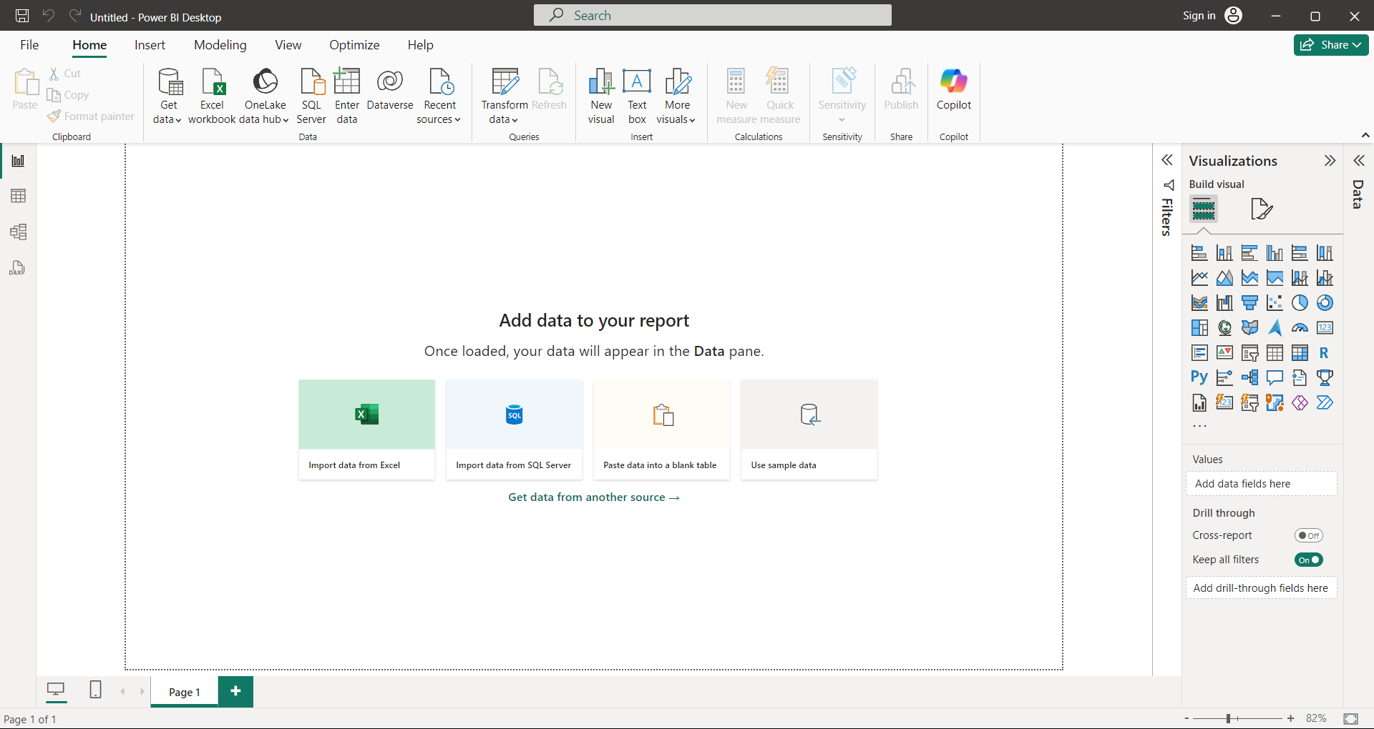

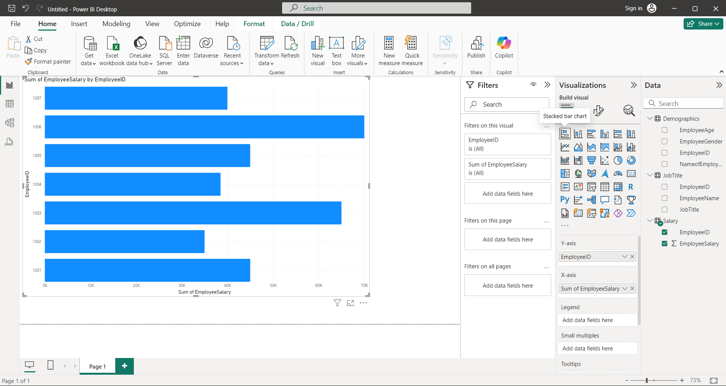

**Expected Outcome:**

* You will understand the components of Power BI and the basic workflow.
* You will be able to load and visualize data in Power BI.
* You will create and save a basic report.

**Experiment 6: Querying Data from CSV - Query Editor, Connecting the data from the Excel Source, Clean, Transform the data.**

**Objective:**

* Connect Power BI to a CSV data source.
* Clean, transform, and load data using the Query Editor.

**Procedure:**

1. **Open Power BI Desktop**  
   Launch Power BI Desktop.
2. **Connecting to CSV Data Source**  
   Click **Home** > **Get Data** > **Text/CSV**.[link](https://docs.google.com/spreadsheets/d/1vcDpkRVYIKvHjQJnR4ODBdqc-1y-XCoqrRjlg7aavHc/edit?usp=sharing)  
   Locate and open your CSV file.  
   Click **Load** after reviewing the preview.
3. **Opening Query Editor**  
   Click **Home** > **Transform Data**.  
   The **Query Editor** will open.
4. **Cleaning and Transforming Data**
   * **Remove unnecessary columns**: Select columns > Right-click > **Remove Columns**.
   * **Renaming columns**: Double-click column headers > Enter new names.
   * **Changing data types**: Select columns > **Data Type** in the ribbon > Choose type.
   * **Filtering rows**: Click drop-down in column headers > Apply filters.
5. **Applying Changes**  
   Click **Close & Apply**. The cleaned data will load.
6. **Creating Visualizations**  
   Use the **Fields Pane** to drag data fields into the **Report View**.  
   Create visualizations (bar chart, pie chart, etc.).
7. **Saving the Report**  
   Click **File > Save**.

**Screenshots/Illustrations:**

**Initial data:**

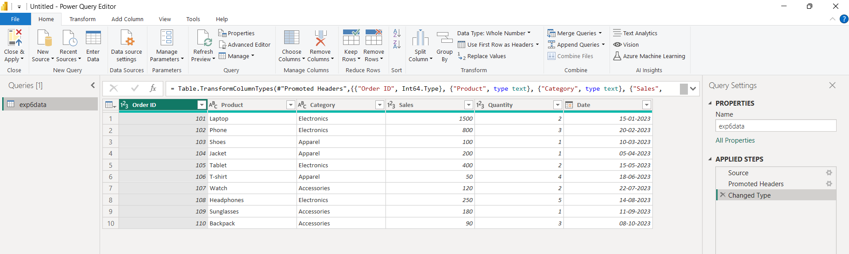

**Transformed data:**

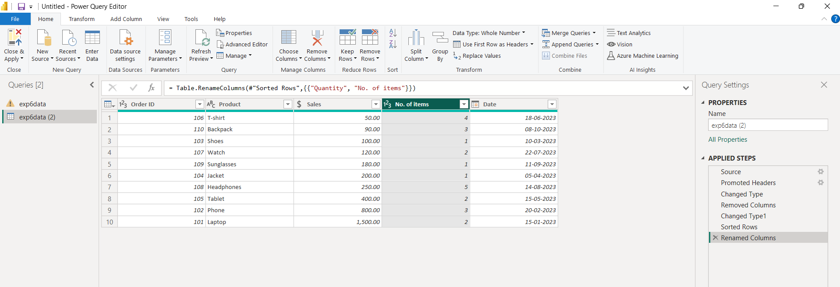

**Product vs sales:**

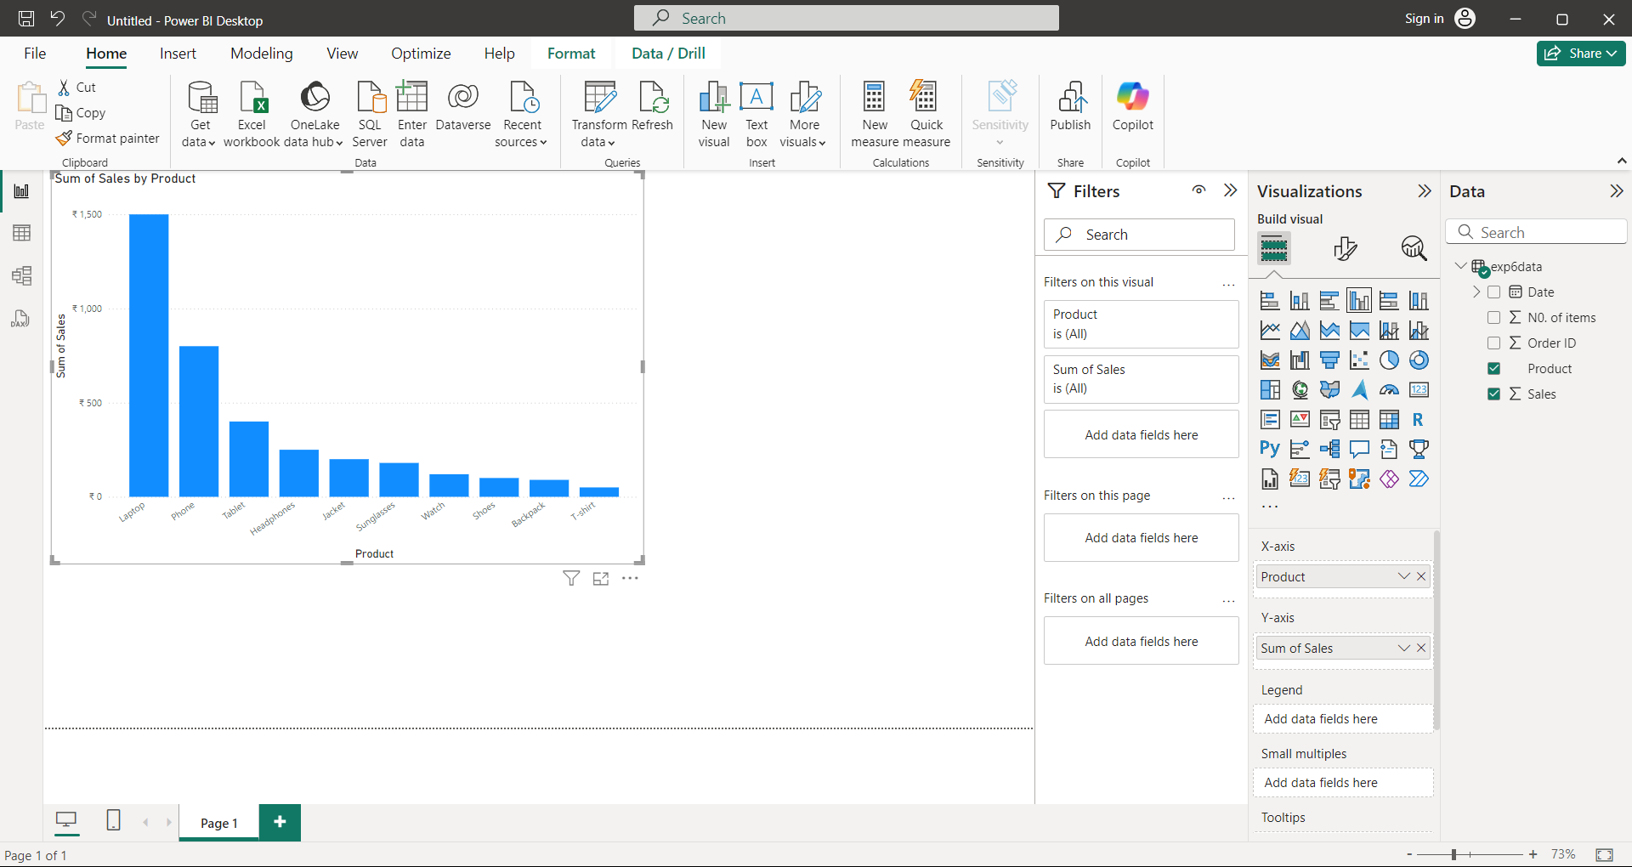

**Expected Outcome:**

* Data from CSV imported and transformed in Power BI.
* Dataset cleaned by removing columns, renaming, and filtering rows.
* Visualizations created from the cleaned data.

**Experiment 7: Creating Reports & Visualizations- Different types of charts, Formatting charts with Title, Colors.**

**Objective:**

* Learn how to create different types of charts in Power BI.
* Format charts with titles and colors.

**Procedure:**

1. **Open Power BI Desktop**  
   Launch Power BI Desktop.
2. **Connect to Data Source**  
   Click **Home** > **Get Data** > **CSV** or another data source.( [sales_category_data.xlsx](https://docs.google.com/spreadsheets/d/1EpONv0qCpTIqaB2a2YaTsmBKA6AQ6s-23ojKqXIfCFc/edit?usp=sharing))  
   Load your dataset into Power BI.
3. **Creating a Bar Chart**
   * Go to the **Visualizations Pane** on the right.
   * Click the **Bar Chart** icon.
   * Drag fields into the **Axis** and **Values** sections.
   * For example, drag **Category** to the Axis and **Sales** to Values to create a sales-by-category bar chart.
4. **Creating a Pie Chart**
   * Click the **Pie Chart** icon in the Visualizations Pane.
   * Drag **Category** to **Legend** and **Sales** to **Values**.
   * This will create a pie chart showing sales distribution by category.
5. **Formatting Charts**
   * Select a chart and go to the **Format Pane** (paint roller icon).
   * Change the **Title**, **Font Size**, and **Color** under the **Title** section.
   * Under the **Data Colors** section, adjust the colors for different data series.
6. **Saving the Report**  
   Once you've created the visualizations, click **File > Save**.

**Screenshots/Illustrations:**

**Bar chart:**

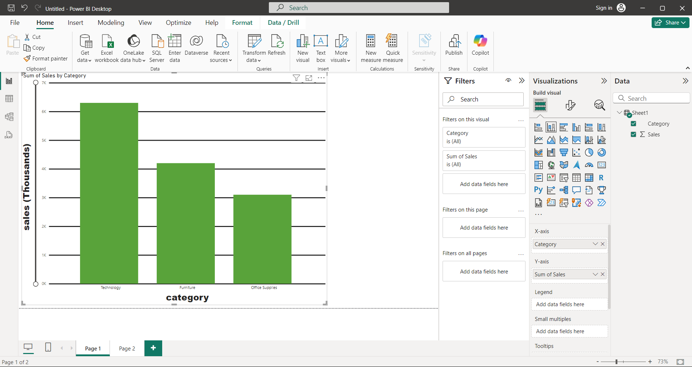

**Pie chart:**

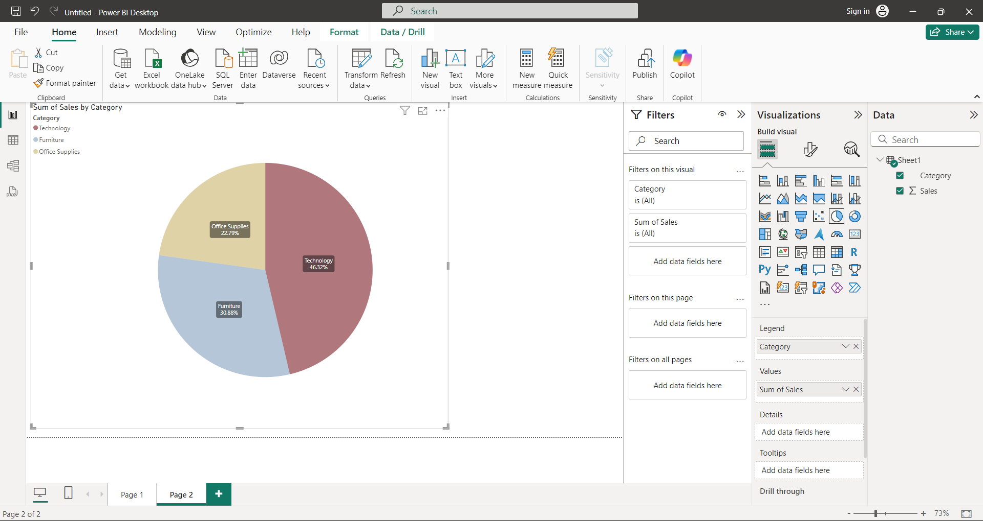

**Expected Outcome:**

* Various charts (bar, pie) created from the dataset.
* Charts formatted with custom titles and colors.

**Experiment 8: Dashboards - Filters in Power BI, Formatting dashboards.**

**Objective:**  
Create and format a dashboard in Power BI to visualize sales data and apply filters, focusing on bar and pie charts.

**Procedure:**

1. **Open Power BI Desktop**  
   Launch Power BI Desktop.
2. **Connect to the Sales Data**
   * Click **Home** > **Get Data** > **Text/CSV**. [link](https://docs.google.com/spreadsheets/d/1vcDpkRVYIKvHjQJnR4ODBdqc-1y-XCoqrRjlg7aavHc/edit?usp=sharing)
   * Load the **Sales Data CSV** we used previously.
3. **Creating Visualizations for the Dashboard**  
   a) **Bar Chart for Sales by Category**
   * In the **Visualizations Pane**, click the **Bar Chart** icon.
   * Drag **Category** to **Axis** and **Sales** to **Values**.
   * The bar chart will show sales for each product category (Electronics, Apparel, Accessories).

b) **Pie Chart for Sales Distribution by Product**

* + Click the **Pie Chart** icon.
  + Drag **Product** to **Legend** and **Sales** to **Values**.
  + The pie chart will show the sales distribution by each product (Laptop, Phone, Shoes, etc.).

1. **Adding Visualizations to the Dashboard**
   * Arrange the **Bar Chart** and **Pie Chart** by dragging and resizing them on the canvas.
   * Position them next to each other to create a clear dashboard layout.
2. **Adding Filters to the Dashboard**
   * In the **Filters Pane**, drag **Category** to **Filters on this page**.
   * This will allow users to filter all visuals on the dashboard based on the product category (e.g., filtering by Electronics).
3. **Formatting the Dashboard**
   * Select each chart and open the **Format Pane** (paint roller icon).
   * Customize chart titles, data colors, and borders.
   * Adjust background colors or borders for a cohesive, professional appearance.
4. **Saving the Dashboard**
   * Click **File > Save** to save your Power BI dashboard.

**Screenshots/Illustrations:**

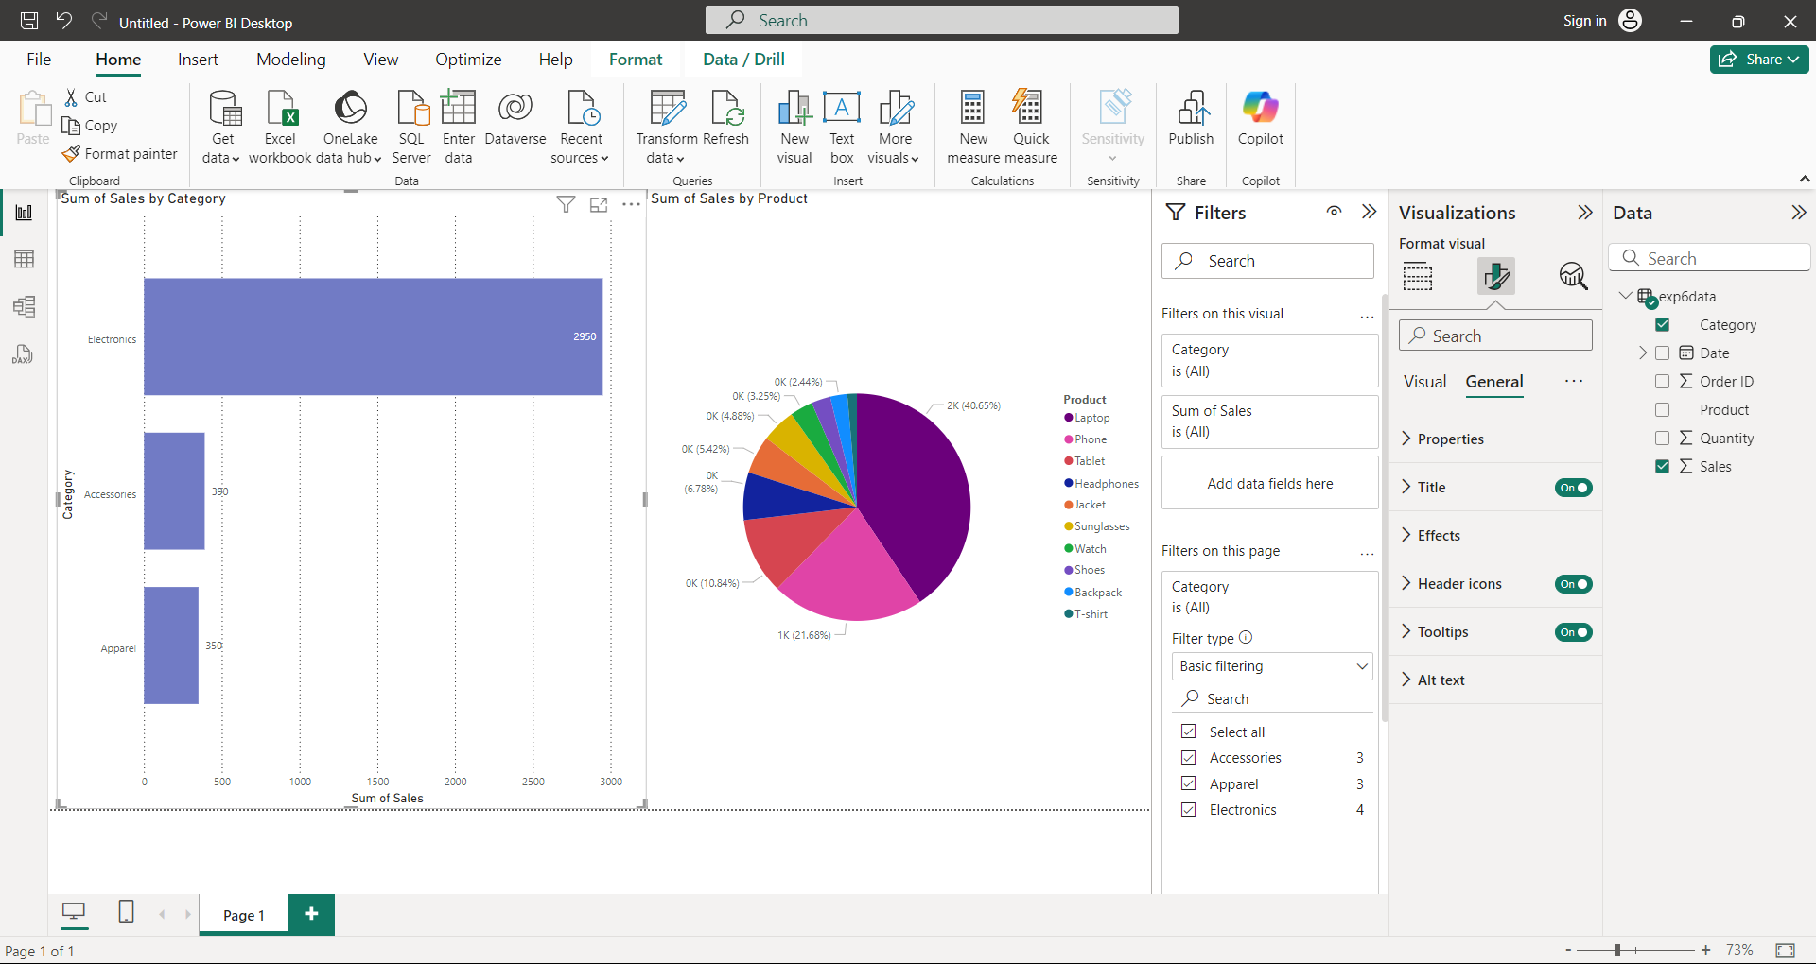

**Expected Outcome:**

* A dashboard with two visualizations:
  + **Bar chart** showing sales by category,
  + **Pie chart** showing sales distribution by product.
* A filter applied to allow users to dynamically filter by product category.

**Experiment 9: Analysis of Revenue in Sales Dataset**

**Objective:**  
Perform advanced visualizations using Power BI to analyze revenue data.

**Procedure:**

1. **Open Power BI Desktop**  
   Launch Power BI Desktop.
2. **Connect to Sales Dataset**  
   Load the [sales](https://docs.google.com/spreadsheets/d/1muttLrPtq4tOaxHtgDMkAn7LvAJ7v2KCIAnWvLyeAZo/edit?usp=sharing) dataset (CSV) into Power BI by clicking **Home** > **Get Data** > **Text/CSV**.
3. **Create the Following Visualizations:**

**i) Choropleth Map (Filled Map) to Show Revenue by State**

* + Click the **Map** visualization in the Visualizations Pane.
  + Drag **State** to the **Location** section and **Revenue** to **Values**.
  + This will create a filled map that shows which state has the highest revenue.

**ii) Line Chart to Show Revenue by Month**

* + Click the **Line Chart** icon in the Visualizations Pane.
  + Drag **Month** to **Axis** and **Revenue** to **Values**.
  + This will display a line chart showing revenue trends over time.

**iii) Create a Bin for Age**

* + Click **Modeling** > **New Group**.
  + Select the **Age** field and create a bin with a size of 10 to group the data.
  + Use this bin to create a new dimension showing the revenue by age groups.

**iv) Donut Chart for Percentage of Revenue per Region**

* + Click the **Donut Chart** icon in the Visualizations Pane.
  + Drag **Region** to **Legend** and **Revenue** to **Values**.
  + Create a calculated field to show the revenue for each region, then adjust the chart for percentage display.

**v) Butterfly Chart Comparing Male and Female Revenue by Product Category**

1. Create Two Bar Charts:

* In the Visualizations Pane, click the Bar Chart icon twice to create two bar charts.
* For both charts, drag Product Category to the Axis section and Revenue to the Values section.

2. Separate Data by Gender:

* In the Filters Pane, for the first bar chart, filter the Gender field to only show Male.
* For the second bar chart, filter the Gender field to only show Female.

3. Reverse One of the Bar Charts:

* Select the bar chart for Female Revenue.
* Go to the Format Pane (the paint roller icon) and expand the Y-Axis section.
* Turn "Reverse" to On. This will flip the direction of the bars for female revenue, creating the butterfly (or tornado) effect.

4. Align the Two Bar Charts:

* Place the Male Revenue bar chart on the left and the Female Revenue bar chart on the right.
* Adjust the size and position of the two charts to align them side-by-side to resemble the butterfly chart.

**vi) Average Revenue per State (Calculated Field)**

1. Go to Modeling > New Measure:
   * In the top menu, click on Modeling.
   * Select New Measure.
2. Enter the DAX Formula:
   * In the formula bar, type the following DAX formula:

**Average Revenue = AVERAGE(Sales[Revenue])**

* + Press Enter to create the measure.

This measure calculates the average revenue for each state in your dataset.

Categorize States as Profitable or Non-Profitable:

1. Create a New Calculated Field for Profitability:
   * Go back to Modeling > New Column to add a calculated column.
   * In the formula bar, use this DAX formula to compare each state's average revenue to a threshold value (e.g., 40,000):

**Profitability Status = IF([Average Revenue] >= 40000, "Profitable", "Non-Profitable")**

1. This will categorize states as either Profitable or Non-Profitable based on the average revenue.

**Use the Calculated Field in Visualizations:**

1. Create a map visualization:
   * Drag the State field to the Location section.
   * Add Profitability Status as a legend to color-code the states based on whether they are profitable or not.
2. **Build a Dashboard**
   * Arrange the visuals created (choropleth map, line chart, donut chart, butterfly chart) on a dashboard.
   * Apply filters based on **Category** or **Region** to make the dashboard interactive.

**Screenshots/Illustrations:**

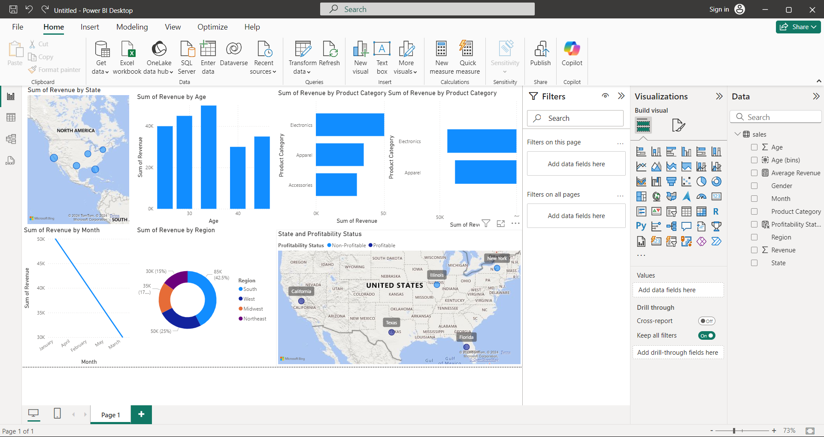

**Expected Outcome:**

* A Power BI dashboard showing:
  + Choropleth map of revenue by state,
  + Line chart of revenue trends over months,
  + Donut chart showing percentage revenue per region,
  + Butterfly chart comparing male and female revenue,
  + Calculated field displaying average revenue per state with profitable and non-profitable states highlighted.

**Experiment 10: Analysis of GDP Dataset.**

**Objective:**

To analyze GDP data from various countries over time using different visualizations such as symbol maps, bar graphs, pie charts, scatter plots, and an interactive dashboard.

**Procedure:**

**1. Import Dataset:**

* **Dataset**: Use a dataset with [GDP](https://docs.google.com/spreadsheets/d/1-qUEVFzBpeikIEU_WTPAHGHHto8cs_r6FT5H_Wa-rdU/edit?usp=sharing) data, containing the following columns:
  + Country
  + Year
  + GDP (in billions)
  + Latitude
  + Longitude
* **Load Dataset into Power BI**:
  + Open Power BI Desktop.
  + Click on **Get Data** and select **CSV** to import the dataset.
  + Load the dataset and inspect it in the data view.

**2. Create Visualizations:**

**i) Symbol Map for Country GDP**

* **Visualize GDP Data by Location**:
  1. Drag **Country** to the **Location** field.
  2. Drag **GDP** to the **Size** field.
  3. Use **Latitude** and **Longitude** in their respective fields.
  4. A symbol map will appear, showing larger symbols for countries with higher GDP.

**ii) Bar Graph for Belgium's GDP (2006 – 2026)**

* **Create a Bar Graph**:
  1. Drag **Year** to the **Axis** field.
  2. Drag **GDP** to the **Values** field.
  3. Apply a filter for **Country** to show only **Belgium**.
  4. You should now see the GDP trend for Belgium over the years.

**iii) Pie Chart for GDP of India, Nepal, Romania, South Asia, Singapore (2010)**

* **Create a Pie Chart**:
  1. Drag **Country** to the **Legend** field.
  2. Drag **GDP** to the **Values** field.
  3. Apply a filter for the **Year** field to show only **2010** data.
  4. The pie chart will now show the proportion of GDP for each country.

**iv) GDP Comparison: Bhutan vs. Costa Rica**

* **Create a Comparison Chart**:
  1. Drag **Country** to the **Axis** field and **GDP** to the **Values** field.
  2. Filter for **Bhutan** and **Costa Rica**.
  3. The chart will display GDP for both countries side-by-side.

**v) Scatter Plot for GDP of Mexico, Algeria, Fiji, and Estonia (2004-2006)**

* **Create a Scatter Plot**:
  1. Drag **GDP** to the **X-Axis** field and **Year** to the **Y-Axis** field.
  2. Drag **Country** to **Details** and select **Mexico, Algeria, Fiji, and Estonia**.
  3. Filter the data for the years **2004 to 2006**.
  4. The scatter plot will display the GDP of these countries over the selected years.

**3. Build an Interactive Dashboard**

* Combine all the visuals (symbol map, bar graph, pie chart, scatter plot) into a single interactive dashboard:
  1. Click on the **Dashboard** tab.
  2. Arrange the visuals on the canvas.
  3. Add slicers or filters (e.g., by year or country) to make the dashboard interactive.
  4. Ensure that interactions between charts are enabled for a dynamic user experience.

**Screenshots/Illustrations:**

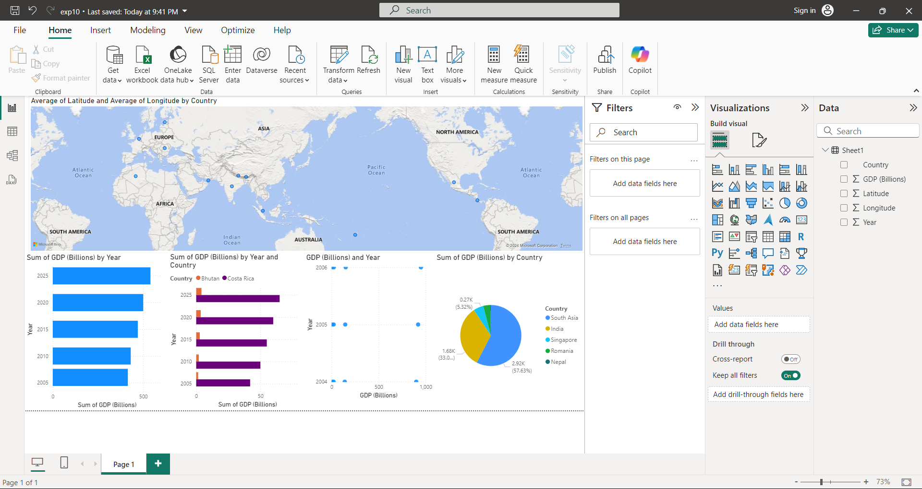

**Expected Outcome:**

* A **symbol map** showing the GDP values for various countries with symbols of different sizes.
* A **bar graph** displaying the GDP trend for Belgium between 2006 and 2026.
* A **pie chart** showing the GDP distribution for India, Nepal, Romania, South Asia, and Singapore in 2010.
* A **comparison chart** visualizing the GDP of Bhutan vs. Costa Rica.
* A **scatter plot** displaying the GDP of Mexico, Algeria, Fiji, and Estonia from 2004 to 2006.
* A **fully interactive dashboard** combining all these elements to provide a comprehensive view of global GDP trends.

**Experiment 11: Analysis of HR Dataset**

**Objective:**

Perform analysis on an HR dataset using Power BI to create different visualizations and calculate metrics such as attrition rate, employee count, job satisfaction, and more.

**Procedure:**

**1. Load the HR Dataset**

1. Open **Power BI Desktop**.
2. Select **Get Data** > **Text/CSV**.
3. Upload the CSV file of the [HR](https://docs.google.com/spreadsheets/d/1fmeMgezQvQZf90UObj6LLOCzQl1nIV7ZjfxggcMdhXE/edit?usp=sharing) dataset.
4. Click **Load** to import the dataset.

**2. Create KPI Metrics**

We'll create several key performance indicators (KPIs) to provide a summary of the dataset.

1. Go to **Modeling** > **New Measure**.
2. Create the following measures:

* **Employee Count:**

Employee Count1 = COUNT(HR[Employee ID])

* **Attrition Count:**

Attrition Count1 = CALCULATE(COUNT(HR[Employee ID]), HR[Attrition] = "Yes")

* **Attrition Rate:**

Attrition Rate = DIVIDE([Attrition Count], [Employee Count], 0)

* **Active Employees:**

Active Employees = CALCULATE(COUNT(HR[Employee ID]), HR[Attrition] = "No")

* **Average Age:**

Average Age = AVERAGE(HR[Age])

**Visualizing the KPIs:**

1. Select **Card Visualizations** from the **Visualizations** pane.
2. Drag each of the KPI fields (e.g., **Employee Count**, **Attrition Count**, etc.) into separate card visualizations.

**3. Lollipop Chart: Attrition Rate by Gender**

To create a lollipop chart (attrition rate by gender):

1. Select **Line and Clustered Column Chart** from the visualizations pane.
2. Drag **Gender** to the **Axis** field.
3. Drag **Attrition Count** to the **Values** field.
4. Drag **Attrition Count** to the **Line Y Axis** field.
5. In the **Format** pane, change the shape and add markers to create a lollipop chart,make **Lines** width to 0px.([refer this vedio for chart](https://www.youtube.com/watch?v=RW-JqP0f4pw))

**4. Pie Chart: Attrition by Department**

1. Select the **Pie Chart** visualization.
2. Drag **Department** to the **Legend** field.
3. Drag **Attrition Count** to the **Values** field.
4. Adjust colors and labels as needed in the **Format** pane.

**5. Bar Chart: Employees by Age Group**

1. Select the **Stacked Bar Chart** visualization.
2. Drag **Age** to the **Axis** field.
3. Drag **Employee Count** to the **Values** field.
4. Use the **Bins** feature to categorize the ages (e.g., 20-30, 31-40, etc.) by right-clicking **Age** and selecting **New Group**.

**6. Highlight Table: Job Satisfaction by Job Role**

1. Select the **Matrix** visualization.
2. Drag **Job Satisfaction** to the **Columns** field.
3. Drag **Employee Count** to the **Values** field.
4. Use color formatting (in the **Format** pane) to create a heatmap-style highlight table.

**7. Horizontal Bar Chart: Attrition by Education Field**

1. Select the **Stacked Bar Chart** visualization.
2. Drag **Education Field** to the **Axis** field.
3. Drag **Attrition Count** to the **Values** field.
4. Adjust the chart to make it horizontal in the **Format** pane.

**8. Donut Chart: Attrition Rate by Gender for Different Age Groups**

1. Select the **Donut Chart** visualization.
2. Drag **Gender** to the **Legend** field.
3. Drag **Attrition Count** to the **Values** field.
4. Create age groups by using the **New Group** feature on the **Age** column.
5. Filter the donut chart by the different age groups to show attrition rates by gender for each group.

**Screenshots/Illustrations:**

**KPI’S:**

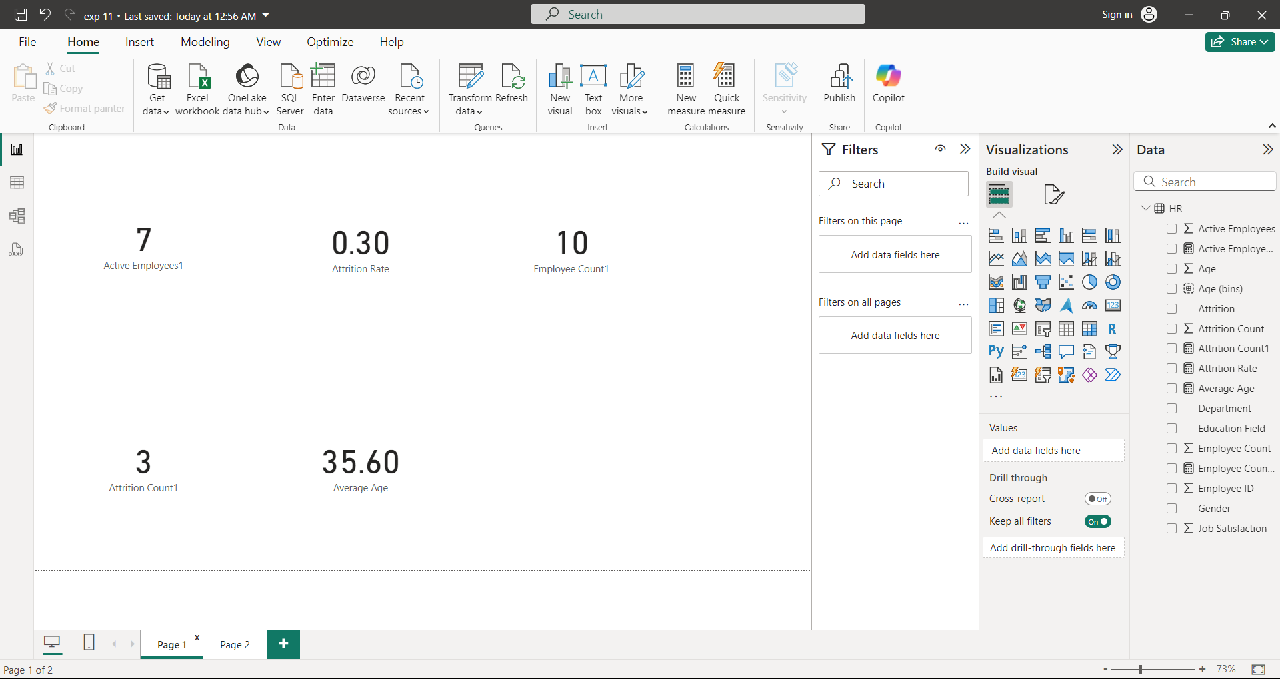

**Charts:**

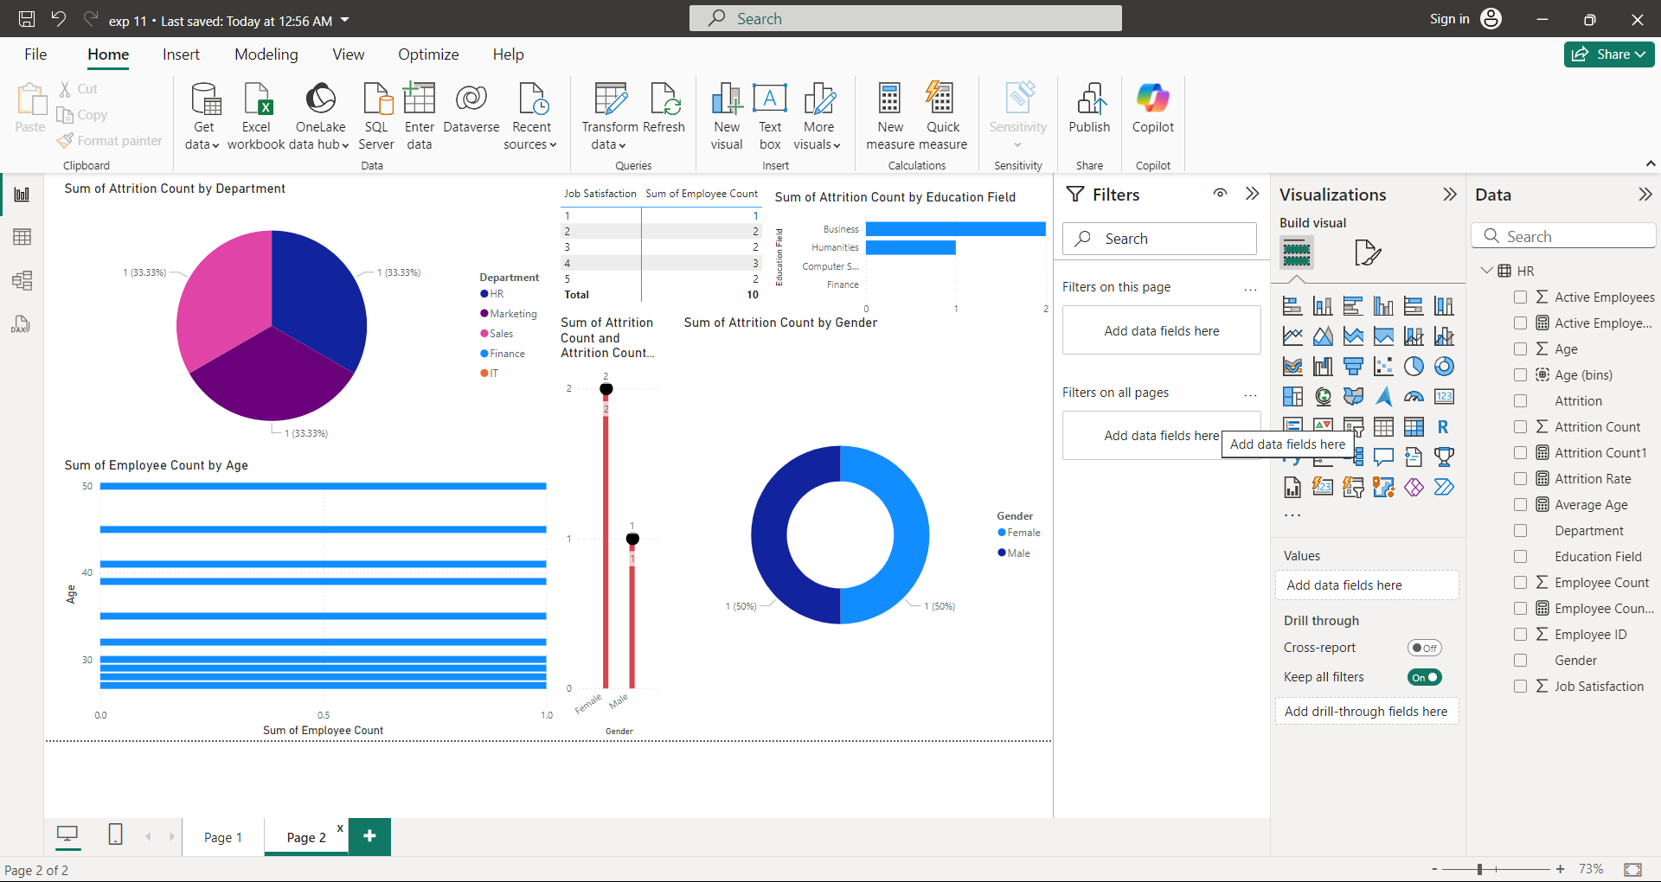

**Expected Outcome:**

* A dashboard containing:
  1. KPIs for employee count, attrition rate, active employees, and average age.
  2. A lollipop chart showing the attrition rate by gender.
  3. A pie chart depicting attrition by department.
  4. A bar chart visualizing employees grouped by age.
  5. A highlight table for job satisfaction by job role.
  6. A horizontal bar chart showing attrition by education field.
  7. Multiple donut charts for attrition rate by gender, categorized by age group.

**Experiment 12: Analysis of Amazon Prime Dataset**

**Objective:**

Analyze the Amazon Prime dataset to create various visualizations using Power BI. This includes creating donut charts, area charts, bar charts, maps, text sheets, and an interactive dashboard.

**Procedure:**

**1. Create a Donut Chart to Show the Percentage of Movies and TV Shows**

1. **Load the Dataset**:
   * Load the [Amazon Prime dataset](https://docs.google.com/spreadsheets/d/1YpIsEFTWavQjxmON3ai3bwNWztPRTADLocsjPQHt_ZE/edit?usp=sharing) into Power BI.
   * Ensure the columns like **Title**, **Type**, **Release Year**, **Genre**, and **Country** are correctly imported.
2. **Create Donut Chart**:
   * From the **Visualizations** pane, select the **Donut Chart**.
   * Drag the **Type** field (Movies or TV Shows) to the **Legend** field.
   * Drag the **Title** field to the **Values** field (this will count the number of titles per type).
   * This donut chart will now display the percentage of movies and TV shows.

**2. Create an Area Chart to Show Releases by Year and Type**

1. **Add an Area Chart**:
   * From the **Visualizations** pane, select the **Area Chart**.
   * Drag the **Release Year** field to the **Axis** field.
   * Drag the **Title** field to the **Values** field (this will count the number of releases).
   * Drag the **Type** field to the **Legend** field to differentiate between movies and TV shows.
2. **Customize the Chart**:
   * Adjust formatting to make the area chart visually clear, with the option to toggle between movie and TV show releases by year.

**3. Create a Horizontal Bar Chart to Show the Top 10 Genres**

1. **Add a Bar Chart**:
   * Select the **Stacked Bar Chart** from the **Visualizations** pane.
   * Drag the **Genre** field to the **Axis**.
   * Drag the **Title** field to the **Values** field.
   * Sort by **Title** in descending order and filter to display the **Top 10** genres.

**4. Create a Map to Display the Total Shows by Country**

1. **Add a Map**:
   * From the **Visualizations** pane, select the **Map** visual.
   * Drag the **Country** field to the **Location** field.
   * Drag the **Title** field to the **Values** field (this will count the total number of shows per country).
   * Power BI will display the number of shows geographically.

**5. Create a Text Sheet to Show the Description of Any Movie or Show**

1. **Create a Slicer**:
   * In the **Visualizations** pane, add a **Slicer**.
   * Drag the **Title** field to the slicer.
   * This will allow you to filter the visualizations by a specific movie or show.
2. **Create a Text Box**:
   * Add a **Card Visual** from the **Visualizations** pane.
   * Drag the **Description** field to the **Card Visual**. This will display the description of the selected movie or show.

**6. Build an Interactive Dashboard**

1. **Combine All Visuals**:
   * Arrange the **Donut Chart**, **Area Chart**, **Bar Chart**, **Map**, and **Text Box** on a single page to create an interactive dashboard.

**Screenshots/Illustrations:**

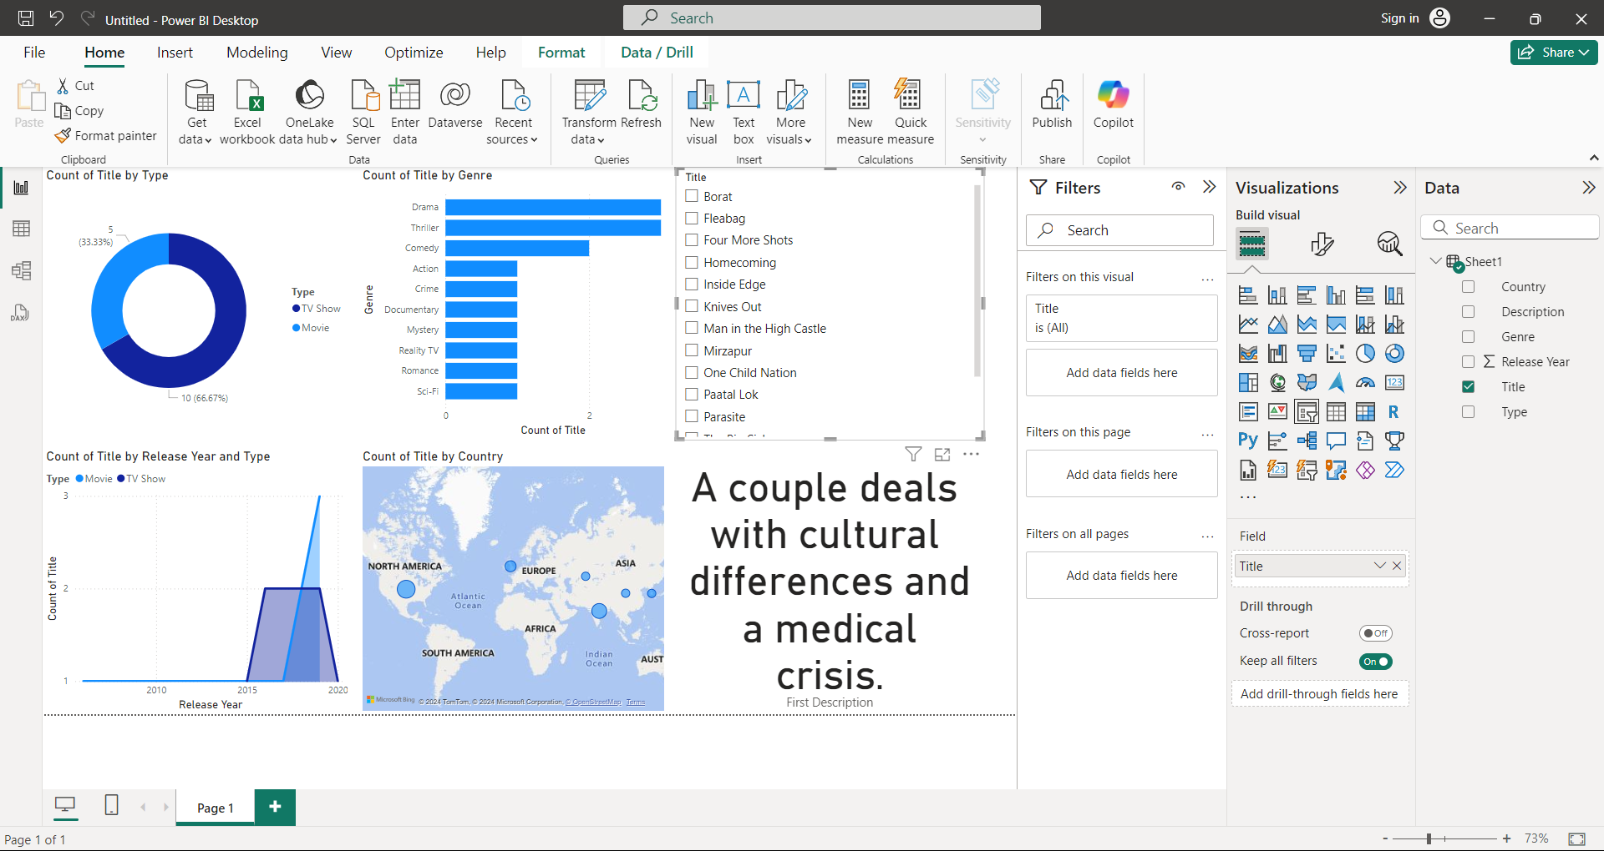

**Expected Outcome:**

* **Donut Chart**: Shows the distribution of movies and TV shows on Amazon Prime.
* **Area Chart**: Displays the release trends by year for movies and TV shows.
* **Bar Chart**: Lists the top 10 genres in terms of number of titles.
* **Map**: Visualizes the geographic distribution of shows and movies.
* **Text Sheet**: Displays detailed descriptions of selected movies or TV shows.
* **Dashboard**: Combines all the visuals into a single interactive dashboard for easy analysis.